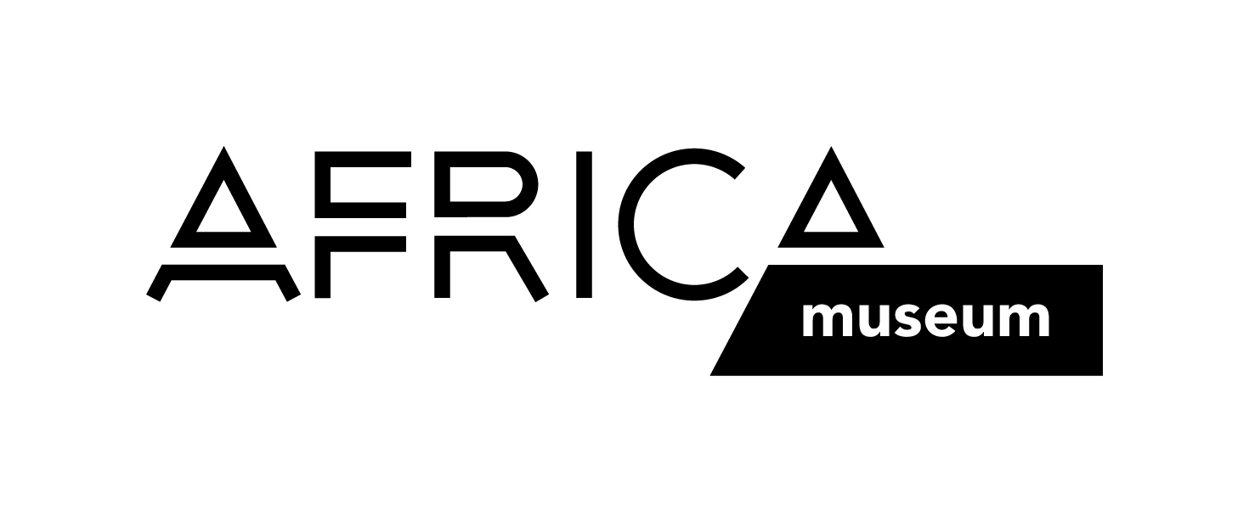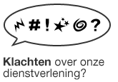

Complaints about our services?

You can report your complaint by filling in your details and comments on this form. This will allow us to handle your complaint properly. Your feedback will help us avoid similar complaints in the future. The AfricaMuseum attaches great importance to the quality of its services.

YOUR DETAILS

Name*………………………………………………………………First Name*………………………………….…….

Street*……………………………………………………………………………………………………………No.*…………

Postal Code*…………………City / Town*…………………………………………………………………………

Phone / Mobile ……………………………………………………………………………………………………………

Email…………………………………………………………………………………………………………………………

*mandatory fields

YOUR COMPLAINT (max. 1000 characters)

Date complaint received ………………………………………………………………………………………

Please send this document to complaints@africamuseum.be.
You can also submit your completed form at the museum reception desk, or send it to:

AfricaMuseum, Complaint Coordinator, Leuvensesteenweg 13, 3080 Tervuren, Belgium.

We will send you an acknowledgment of receipt shortly. You will receive a response to your complaint within 15 working days after submission.

