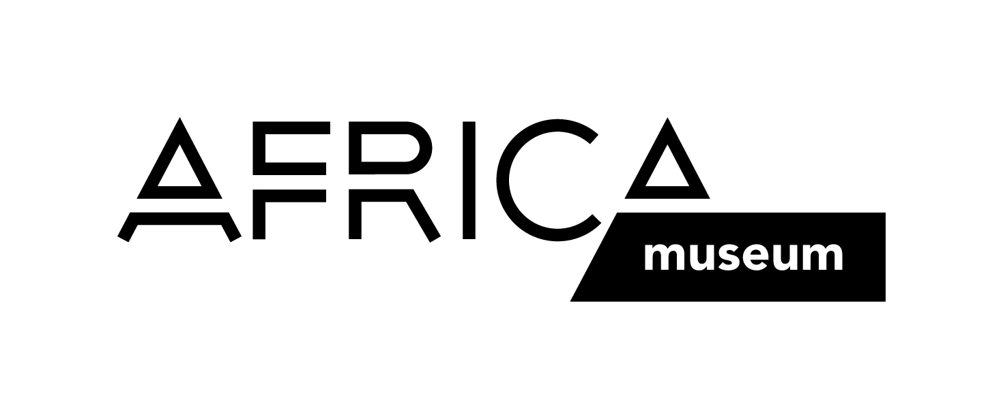

Information form

for the loan of objects from the departments of Cultural Anthropology

and/or History of the RMCA Tervuren
Exhibition
Title:
Dates of the exhibition: from until
Duration of the loan: from until

Organizer
Institution / organisation:
Person in charge:
Contact person:
Address:
Tel.:
Fax:
E-mail:
VAT number (for Belgian organizers):

Contractor (in case this is not the organizer)
Organisation / company:
Person in charge:
Contact person:
Address:
Tel.:
Fax:
E-mail:
VAT number (for Belgian organizers):

Exhibition venue (in case this is different from the address of the organizer)
Place of the exhibition:
Person in charge:
Contact person:
Address:
Tel.:
Fax:
E-mail:

Reproductions
Do you require photographic reproductions in the context of this loan? no yes

Will there be a catalogue? no yes

Will the catalogue contain images of the objects on loan? no yes

Note: All requests for photographic reproductions must be sent separately. Please find the general conditions for the supply of photographic reproductions, as well as the appropriate form, on the website: http://www.africamuseum.be/collections/reproductions

Please fill out this form and send it a.s.a.p. to the following address:

Royal Museum for Central Africa
Division of Collection Management
The Loans Secretariat
Leuvensesteenweg 13
3080 Tervuren
Belgium
Tel.: +32 (0)2 76 95 740
Fax: +32 (0)2 76 95 800

or by e-mail to loan@africamuseum.be.

